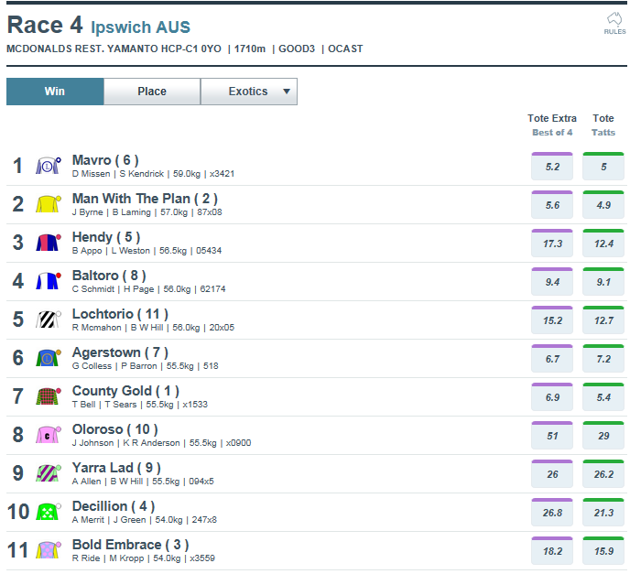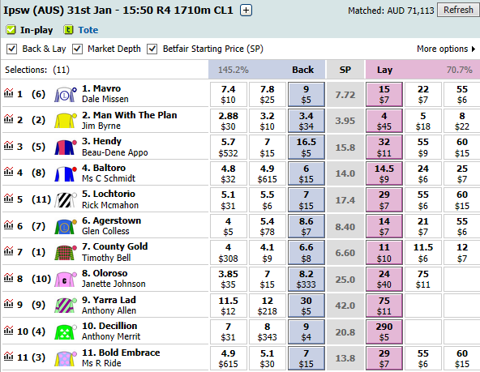
That one page is now replaced by two. Considering I’ve got my screen split with oncourse flucs and fixed prices on one side, the old page on the left & spreadsheet in the centre, it displayed everything I needed to make a last minute decision. Now I can’t split my screen 4 ways under the new change and I can’t display the BF racecard in order of price. A backwards step!
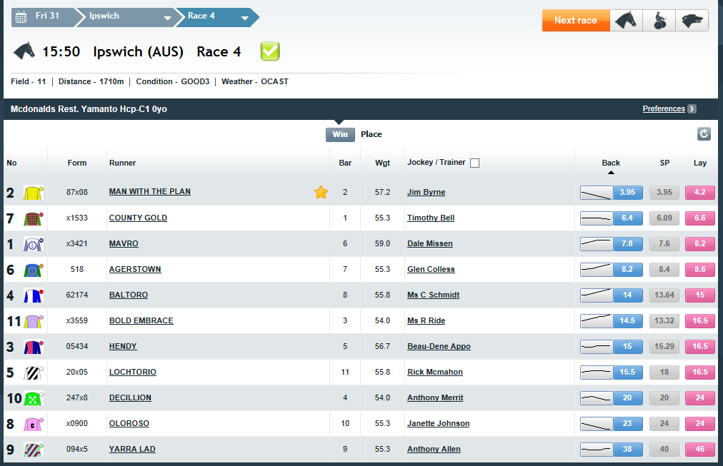
The old screen. It had last 5 starts, price movement graph, ability to display in order of favouritism, countdown to close clock

